Summer Holiday Club 2018
Two days of creative play, music and drama on the themes of Jonah and Joseph for the children aged 5-11 years
Each day includes lunch and refreshments. There is no charge, but we ask for donations to help cover the costs.
Dates
Jonah - Tuesday 14th August 2018 – 10.00am – 3.00pm – St Mary’s Church, Church Street, Calne SN11 0HU
Joseph - Friday 31st August 2018 – 10.00am – 3.00pm – Christ Church, Church Road, Derry Hill sn11 9NN
If you would like to book for your child/children to attend either or both of these days please can you contact Diane Saxty – email: diane@mardenvale.org.uk Tel: 07846244726 or Sadie Kenway – email:calnepcc@gmail.com Tel: 01249816522

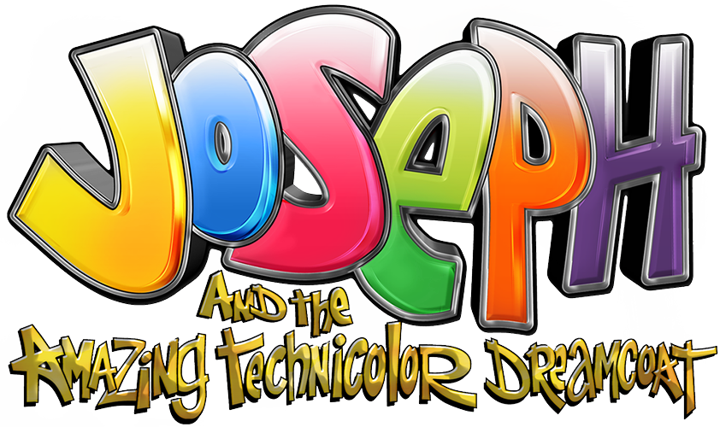
Child/Childrens Name/s

Parents’/Guardians’ names
Full Address
Email Address
Telephone Number
Mobile Number
Club Attending:  St Mary’s church, Calne  14th August 2018  --------------------------------  Christ Church, Derry Hill  Friday 31st August 2018 | Yes / No  ------------------------------------------------------------------------------------------  Yes / No
Mailing List for future Children Events | Yes / No
Known Allergies for Child/Children attending | Yes /No If Yes please list below
Known medical condition for Child/Children attending | Yes/No If Yes please list below
Booking Form

I/we* consent to my child/children named above, attending the Holiday Club on the days selected above
Parent’s/Guardian’s Signature

--------------------------------------------------------------------------------------------------------------------------------------
Date: ________________________

To view our safe guarding policy for children and vulnerable adults visit www.parishofcalneandblackland.org.uk/

